Proposal Narrative for the 2021 RMS-SEPM Edwin D. McKee Research Grant Maya Yamei Bradford

Hello, my name is Maya Yamei Bradford. I am a first-year masters student at West Virginia University working on a thesis with Dr. Kathy Benison. It would be a privilege to honor Edwin McKee’s legacy through my work.
The title of my masters thesis is “Gypsum textural records of saline environments from the Triassic Red Peak Formation.” I will use fieldwork and petrographic observations to investigate previously undescribed bedded and diagenetic gypsum from outcrops of the iconic Chugwater Group near Shell, Wyoming. I will describe in detail ancient sediments from my favorite place (Wyoming) and look to modern analogs for suitable explanations. In the spirit of Dr. McKee’s work (e.g. McKee et al., 1959; McKee, 1964), this proposed research is a comparative sedimentological study that is rooted in love of place.
The Chugwater Group is a distinctive red, fine-grained siliciclastic succession that is well exposed around the flanks of Laramide uplifts in northern and central Wyoming. Interpretations of depositional environments have been controversial. Early workers suggested marine deposition, based largely on the presence of abundant gypsum and rare, thin carbonates (Tomlinson, 1916; Branson, 1927; Picard, 1967; High and Picard, 1969). These traditional marine interpretations were made before an acceptable framework of red-bed and evaporite deposition in continental environments using comparative sedimentology was established (e.g., Walker, 1967; Lowenstein and Hardie, 1985). Since then, the processes by which evaporites, carbonates, and red beds accumulate in modern and ancient continental settings has been documented (i.e., Benison et al., 2007; Benison and Goldstein, 2000, 2001; Foster, 2014). Today, there is a large body of work describing both modern and ancient halites, gypsums, carbonates, and redbeds that have formed in saline lake and groundwater systems. Most ancient examples of extreme acidic saline settings existed from the middle Permian to early Triassic, corresponding roughly to the biotic crisis in which ~90% of all existing species on Earth went extinct.
The Chugwater Group is composed of four formations. At the base, the Red Peak Formation is the thickest and most laterally persistent of these four formations (Fig. 1). A thin, ambiguous unit of hard, white carbonate mudstone known as the Alcova Limestone sits above the Red Peak Formation (Love, 1939; McKee et al. 1959; Picard, 1967; High and Picard, 1969). The Alcova Limestone is overlain by the Crow Mountain Sandstone and the Popo Agie Formation.
The most detailed sedimentological observations of the Chugwater Group were made by Knapp in his 2020 PhD dissertation. Knapp (2020) examined outcrops of the Goose Egg Formation, the Red Peak Formation and Alcova Limestone, but found no evidence of marine influence, concluding that these red beds and evaporites were deposited in alluvial plains with salt lakes, mudflats, loess, and soils. However, Knapp’s (2020) work on the Red Peak Formation focused on the siliciclastics and not the bedded gypsum near the top of the formation. Detailed descriptions of bedded gypsum and red beds in north-central Wyoming, and throughout much of the Permo-Triassic redbeds and evaporites of the Rocky Mountain region, have not been made. What were the specific environments that deposited bedded gypsum? Does the gypsum in the Red Peak represent lake deposits, spring deposits, eolian deposits, and/or gypcrete soil horizons? A closer examination of the gypsum beds in the upper Red Peak Formation is needed to establish a refined understanding of the early Triassic environments of the Rocky Mountain region, as well as better understanding of ancient gypsum/anhydrite rocks in general.

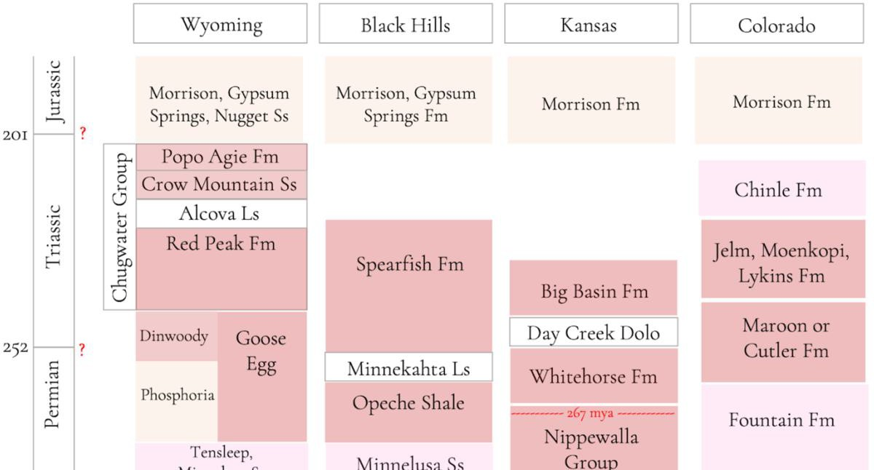

Figure 1: Abundant Permian and Triassic red bed and evaporite deposits in the U.S. midcontinent. Detailed studies of some of these rocks indicate extreme environment including acid saline lake waters (e.g., Benison et al., 1998). The red colored units are red beds and evaporites. Pink boxes are units with some red beds. The carbonate formations, depicted here by white boxes (the Alcova Ls, Minnekahta Ls, and Day Creek Dolomite), were gypsum deposits that have been diagenetically replaced by calcite and dolomite (Benison et al., 2018; Knapp, 2020).

My thesis will be field-based and combines outcrop observations and thin section petrography to reveal clues about depositional environments. I will study four outcrops in northcentral Wyoming that contain bedded gypsum, but also likely contain diagenetic gypsum (Fig. 2 and 3). My centimeter- and millimeter- scale investigation of the textures of these gypsums will further refine what kinds of saline environments are represented in the Red Peak. For example, if I see a beds of bladed or needle-shaped, upwards-pointing gypsum/anhydrite crystals, I would likely interpret it as a saline lake deposit. However, if there are rounded, sorted, and frosted gypsum grains with cross-bedding, I would interpret an eolian deposit (Fig. 4).
I hypothesize that the gypsum/anhydrite in the upper Red Peak Formation represent deposition during some stage of a saline lake system. I will use the model for saline lake depositional cycles outlined by Benison and Goldstein (2001), supplemented by observations of modern saline lake systems in Western Australia (Benison et al., 2007), to make interpretations of depositional environments and diagenetic history based on my observations. From my field and petrographic observations, I will interpret depositional environments and diagenetic history, and I’ll then combine these interpretations to make a model of the depositional system.

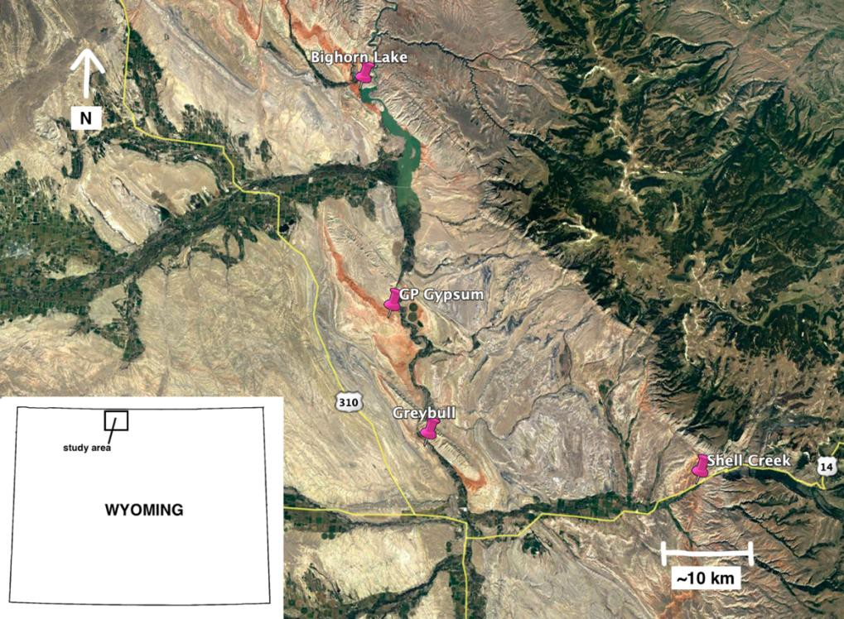
Figure 2: Google Earth Pro aerial imagery of field area, with outcrop GPS waypoints depicting locations of four targeted outcrops to be studied in detail as part of this proposed research.

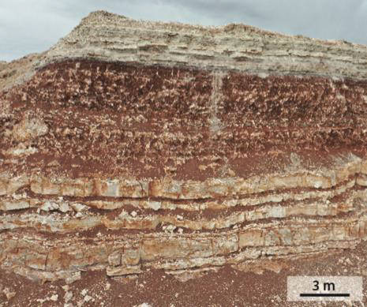
Figure 3: An outcrop of the upper Red Peak Formation exposed at the Georgia-Pacific Gypsum mine, Shell, WY (photo courtesy of J. Knapp).

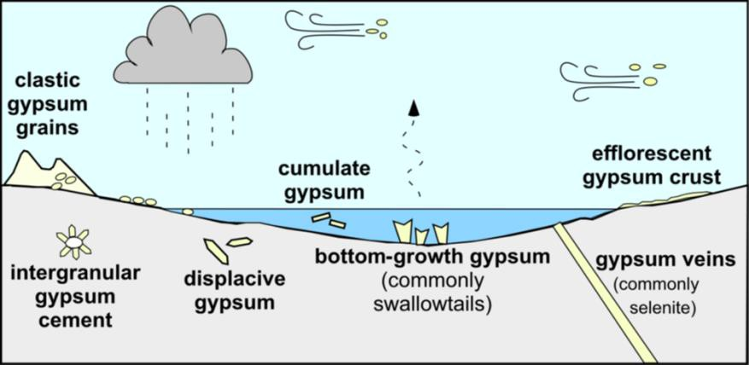
Figure 4: Seven different kinds of depositional and diagenetic gypsum. Each gypsum type can be recognized by a discrete texture (Benison, pers. comm.)

I will compare my results to deposits of alluvial fans and plains, saline lakes, mudflats, loess, and soils interpreted for the Goose Egg Formation, Red Peak Formation, and Alcova Limestone by Knapp (2020). I will also compare my results to the nearby, age-equivalent saline lakes, mudflats, and paleosols represented in the Minnekahta Limestone and Opeche Shale in western North Dakota and South Dakota (Benison et al., 2018; Benison and Goldstein, 2000). My results will further be compared to those from the gypsum and red beds of the Nippewalla Group in Kansas and Oklahoma (i.e., Benison and Goldstein, 2001; Benison et al., 2015) and the Triassic Mercia Mudstone Group in Northern Ireland (Andeskie et al., 2018).
This grant will allow me to travel to Wyoming to conduct fieldwork this summer (2021), to make thin sections, and perform mineral identification by XRD. I plan to submit an abstract of my preliminary results for presentation during the SEPM-sponsored student poster session at the 2021 GSA Annual Meeting. After completing and defending my thesis, I will write a manuscript for submission to either The Mountain Geologist or Rocky Mountain Geology. I will also submit an abstract for either a poster session or a talk at the 2022 GSA Annual Meeting.
Like Dr. McKee, I love with my soul the stacked and tilted sediments of western North America. I am inspired by McKee’s legacy as a describer and correlator of ancient western sediments and it would be a privilege to honor him through this project. As a young Taiwanese woman, I strive to promote the field of sedimentary geology and make it accessible to all people through my research, my teaching, and my public outreach.
Thank you for your consideration of my application.

References

Andeskie, A.S., Benison, K.C., Eichenlaub, L.A., and Raine, R., 2018, Acid-saline-lake systems of the Triassic Mercia Mudstone Group of County Antrim, Northern Ireland: Journal of Sedimentary Research, v. 88, p. 385-398.

Benison, K.C. and Goldstein, R.H., 2000, Sedimentology of ancient saline pans: An example from the Permian Opeche Shale, Williston Basin, North Dakota: Journal of Sedimentary Research, v. 70, p. 159-169.

Benison, K.C. and Goldstein, R.H., 2001, Evaporites and siliciclastics of the Permian Nippewalla Group, Kansas and Oklahoma: A case for nonmarine deposition: Sedimentology, v. 48,
p. 165-188.

Benison, K.C., Bowen, B.B., Oboh-Ikuenobe, F.E, Jagniecki, E.A., LaClair, D.A., Story, S.L., Mormile, M.R., and Hong, B.Y., 2007, Sedimentology of acid saline lakes in southern Western Australia: Newly described processes and products of an extreme environment: Journal of Sedimentary Research, v. 77, no. 5, p. 366-388.

Benison, K.C., Goldstein, R.H., Wopenka, B., Burruss, R.C., and Pasteris, J.D., 1998, Extremely acid Permian lakes and groundwaters in North America: Nature, v. 392, p. 911-914.

Benison, K.C., Knapp, J.P., DiFrisco, A.J., and Rasbury, E.T., 2018, The Permian Minnekahta Limestone: A saline lake gypsum replaced by calcite: The Mountain Geologist, v. 55, n. 2,
p. 59-73.

Benison, K.C., Zambito, J.J., and Knapp, J.P., 2015, Contrasting siliciclastic-evaporite strata in subsurface and outcrop: An example from the Permian Nippewalla Group of Kansas, U.S.A.: Journal of Sedimentary Research, v. 85, p. 626-645.

Branson, E.B., 1927, Triassic-Jurassic “red beds" of the Rocky Mountain region: The Journal of Geology, v. 35, p. 607–630.

High, L.R., and Picard, M.D., 1969, Stratigraphic relations within upper Chugwater Group (Triassic), Wyoming: AAPG Bulletin, v. 53(5), p. 1091-1104.

Knapp, J.P., 2020, Alluvial fans, loess plains, lakes, and distributive fluvial systems: Depositional systems of the Permian-Triassic red beds and evaporites of Wyoming (U.S.A.): unpublished Ph.D. dissertations, West Virginia University ETD.

Lowenstein, T.K. and Hardie, L.A., 1985, Criteria for the recognition of salt-pan evaporites:
Sedimentology, v. 32, p. 627–44.

McKee, E.D., 1964, Problems on the recognition of arid and of hot climates of the past: in, Problems in palaeoclimatology: Interscience Publishers, London, p. 367–377.

McKee, E.D., Goldsmith, J.W., Ketner, K.B., McLachlan, J.C., Hindle, M., and Rhodes, M., 1959, Paleotectonic maps of the Triassic system: U.S. Geologic Survey Numbered Map Series I-300.

Picard, M.D., 1967, Stratigraphy and depositional environments of the Red Peak Member of the Chugwater Formation (Triassic), west-central Wyoming: Rocky Mountain Geology, 6, p.39–67.

Tomlinson, C.W., 1916, The origin of red beds: A study of the conditions of origin of the Permo- Carboniferous and Triassic red beds of the western United States: The Journal of Geology, v. 24, p. 238–253.

Walker, T.R., 1967, Formation of red beds in modern and ancient deserts: Geological Society America Bulletin, v. 78, p. 353–368.

