Chronstratigraphic correlation of Colorado River terrace deposits -- deciphering the Quaternary evolution of salt tectonics and the formation of Cataract Canyon, Utah Tanski, Natalie

Purpose:
The Needles District of Canyonlands National Park, Utah is marked by an array of active faults formed in brittle rocks overlying the ductile evaporites of the Pennsylvanian Paradox Formation (Mcgill and Stromquist, 1975; Stromquist, 1976). This system of normal faults and grabens accommodate sliding and collapse of topography to the northwest into the open boundary of Cataract Canyon along the Colorado River (Fig.1). The general consensus is that incision by the river has removed constraining mass and resulted in flow of the evaporites at depth, while the gentle dip of the Permian and Pennsylvanian strata towards the canyon resulted in lateral expansion of the brittle plate downslope into the river canyon (McGill and Stromquist, 1979; Huntoon, 1982; Kravitz et al., 2017). This deforming region culminates along Cataract Canyon with several salt diapirs and an observable increase in mass-wasting into the river (Fig. 1). Geomorphically, Cataract Canyon is a poorly understood, steep, “knickzone” anomaly along the Colorado River profile. The contrast in geomorphology and structural deformation is especially stark between Cataract and the reach of the Colorado River upstream
-- Meander Canyon. Upstream the river is wider, flows at a very low gradient, and little to no salt-related deformation exists. To gain insight on what caused the steepness anomaly in Cataract Canyon I have developed multiple working hypotheses that use a series of Pleistocene river terraces along the length of Meander Canyon. I propose to test these hypotheses on the evolution of Cataract Canyon by establishing and interpreting the spatial and temporal pattern of Colorado River terraces in Meander Canyon via surveying, mapping, and luminescence dating of Pleistocene river deposits. River terraces provide direct markers of past baselevel and with numeric age control can reveal geometric changes to the river that can help build an understanding of regional or tectonic influences. Thus, my results will aid in understanding the Quaternary evolution of Cataract Canyon, help resolve our understanding of the classic regional problem of the Needles fault zone and the complicated interplay between canyon incision, salt tectonics, and geomorphology. I seek funding to cover remaining geochronology costs for key samples necessary to test my hypotheses.

Background:
Evolution of Cataract and Meander Canyons
The longitudinal profile of the Colorado River across the Colorado Plateau is marked by three major knickzones; Grand Canyon, Cataract Canyon, and Westwater Canyon. Knickzones are steep reaches that deviate from a concave, smooth longitudinal profile (Hack et al., 1957). Knickzones can form for a variety of reasons including transient response to baselevel fall, locally higher rock uplift rate, more resistant bedrock, or local coarse sediment input. The Grand Canyon knickzone is locally pinned in place due to resistant lithology and coarse tributary debris input (Cook et al., 2009; Bursztyn et al., 2015), while Westwater Canyon is hypothesized to be a young knickzone from rapid late-Pleistocene transient incision (Jochems and Pederson, 2015). Between these two contrasting knickzones lies Cataract Canyon, starting at the confluence of the Green and Colorado Rivers. Cataract Canyon is the greatest steepness anomaly along the Colorado River (Pederson and Tressler, 2012) and it includes the added complexity of salt tectonics, where river incision, salt flow, and structural deformation are theoretically linked (Huntoon, 1982; Kravitz et al., 2017). Upstream of Cataract Canyon in Meander Canyon, the river flows at a low gradient through a deformed river anticline

of Permian and Pennsylvanian sedimentary strata. In Cataract Canyon as the gradient of the river steepens ten-times in a debris-fan and talus dominated canyon, the same bedrock walls are jointed and deformed along a river anticline, the hillslopes and channel are littered with boulders, and four salt diapirs are present on the eastern side of the channel.
This sudden change in river character within Cataract Canyon has several potential explanations. One hypothesis is that increased sediment supply to the river in the Holocene has impounded it, steepening its profile (Webb et al., 2004). Upstream in Meander Canyon, Pleistocene gravel terrace deposits have been observed to submerge below the current grade of the river with decreasing distance to Cataract Canyon (Webb et al., 2004). The open boundary of Cataract Canyon allows for rigid overburden strata to laterally spread down dip into the canyon corridor from its eastern side (Huntoon, 1982). Observations indicate landslides and/or rockfalls exist along the immediate cliffs of the canyon. Cataract Canyon could also be impounded due to debris flows, and Webb et al., (2004) specifically hypothesizes the source is the Permian Halgaito Shale in the cliffs above the river. Studies elsewhere on this river system show a link between debris fans, rapids, and channel slope (Grams and Schmidt, 1999; Elliott, 2002; Hanks and Webb, 2006). A second hypothesis for the steep gradient of Cataract Canyon relates to bedrock strength. A study on rock strength along the Colorado River reveals that the limestones in Cataract Canyon are relatively resistant, and may be a cause in the formation of this knickzone (Bursztyn et al., 2015). A third hypothesis is that rock uplift due to salt diapirsm is maintaining the steep profile. Upper Cataract Canyon contains salt diapirs along its riverbank while the lower section exposes the upper Paradox Formation in stratigraphic position (Huntoon, 1982). InSAR analysis demonstrates that salt-related deformation is active and apparently generating 2-3 mm/yr of upward movement along the canyon floor (Furuya et al., 2007).
Ultimately, these three hypothetical controls -- sediment supply, bedrock strength, and salt tectonic driven uplift -- could be acting together to cause knickzone formation and it is unclear if Cataract Canyon is a transient or stable geomorphic feature. Regardless, river incision beyond a threshold stratigraphic depth within the Permian and Pennsylvanian strata initiated salt flow and local deformation (Kravitz et al., 2017). Currently, incision of Cataract, triggering onset of salt tectonics, is estimated to be 0.2 to 1.0 Ma (Mcgill and Stromquist, 1975; Geiger, 2014). Temporally constraining the Colorado River’s response upstream through the Quaternary will aid in understanding the drivers and timing of salt tectonic landscape evolution in Cataract Canyon and the chronology of the terraces upstream in Meander Canyon can serve as a test for the three outlined hypotheses on the evolution of this knickzone anomaly (Fig.2).
Geochronology: Luminescence Dating
Luminescence dating applied to fluvial sediments provides numeric age control for river terrace formation. This technique provides an age estimate of the last time quartz or feldspar sand was last exposed to sunlight thus giving an age of deposition (Huntley et al., 1985). Once buried, grains accumulate electrons in crystal lattice irregularities from exposure to low-level ionizing radiation from radioisotopes in the surrounding sediment and cosmic radiation, with the pace of accumulation referred to as the dose rate. This dating technique can provide an age up to the sample’s saturation (i.e. when all traps are filled), generally limited to samples <200 ka for quartz but up to ~1 Ma for feldspar (Arnold et al., 2015). The natural luminescence signal, caused by trapped electron release, is measured by stimulation in the lab and is proportional to its burial age and dose rate (Aitken, 1998; Rhodes, 2011). The dose of lab radiation that produces a luminescence signal equivalent to the natural dose is called the equivalent dose. Application of this method to fluvial terraces requires targeting fine sand lenses near the strath of the deposit. Sampling involves collecting sand in an opaque tube for

measuring the luminescence signal and a sample of the surrounding sediment (~30 cm radius) for measurement of the dose rate (Nelson et al., 2015). Processing occurs in a dark lab to isolate quartz and feldspar following standard procedures. The equivalent dose is measured in the lab via a Risø TL/OSL DA-20 reader following the single-aliquot regenerative method (Murray and Wintle, 2000). The age of burial is then calculated by dividing the equivalent dose by the dose rate (Rittenour, 2008).

Research Design: Chronology and correlation of river terraces in Meander Canyon
The above outlined hypotheses on the formation of the Cataract Canyon knickzone can be tested with spatial and temporal correlation of river terraces upstream in Meander Canyon (Fig. 2.). In Meander Canyon it is observed that Pleistocene terrace deposits seem to gradually decrease in height above the river, as they converge or project below grade approaching Cataract Canyon. This has been hypothesized as caused by Holocene impoundment by mass movements in Cataract Canyon (Webb et al., 2004). Correlating the individual gravel remnants in not possible based on mapping alone because of the discontinuous and sparse preservation, especially downstream through Meander Canyon. Therefore, numerically dating terrace deposits along Meander Canyon is essential for testing alternate hypotheses (Fig. 2). The correlation of terrace deposits downstream toward Cataract Canyon could also be a function of the canyon narrowing not having the accommodation space to preserve terraces (Fig. 2B). Preservation of terrace deposits requires a valley wide enough to accommodate alluviation that is partly preserved, and not totally removed, upon subsequent incision (Pazzaglia, 2013). In this case, Cataract Canyon steepness could be due to resistant bedrock or be a transient feature that is migrating up the river profile. Third, the downstream decrease of terrace deposits or apparent convergence might be due to differential incision above an anchored or uplifting knickpoint (Fig. 2C). If the Cataract Canyon knickzone is partially pinned in place as a function of local salt-tectonic uplift, then incision recorded by terrace deposits would increase upstream away from this local baselevel.
Colorado River terrace deposits in Meander Canyon from the Portal (exit of Moab Valley) to where they disappear above the confluence have been surveyed with a research- grade GPS, mapped, and sampled for luminescence dating techniques to develop spatial and temporal relationships with downstream distance. I have nearly completed the fieldwork aspect of this research and I am currently in the data processing and analysis stage. I have documented terrace height above the river, measured deposit thickness, surveyed cross- sectional transects of terrace deposits, and mapped surficial deposits. Bedrock geology in this area was previously mapped, but the deposits relevant to this research are not mapped with the detail nor the precision needed for this study. All possible dating targets found during fieldwork in Meander Canyon have been sampled, considering that the limitation for luminescence dating lies in finding sand bodies within the thin, gravel-dominated terrace deposits (Fig. 1). Additionally, there is a series of terraces that have been previously dated by our research group in the center of the study area that will be incorporated in this research (Fig. 3). I have collected 12 new luminescence samples, which have been processed at the USU Luminescence Lab and are in the initial analysis stage. Three additional samples have been recently collected and are awaiting processing and one more key sample is still needed to be collected. Additional funding for this research is needed to cover geochronology costs for half of the collected luminescence samples. Initial results are suggesting that chronostratigraphic relationships of the river terraces are either following hypothesis A or C from Figure 2 (Fig. 3). The findings of my study will aid in resolving the complex system of the Needles fault zone, halokenesis, and canyon cutting, in this famous yet poorly understood region.

Budget:
Item | Cost | Have | Need
Luminescence Analysis: $250/sample | 16 samples = $4000 | $2000 | $2,000

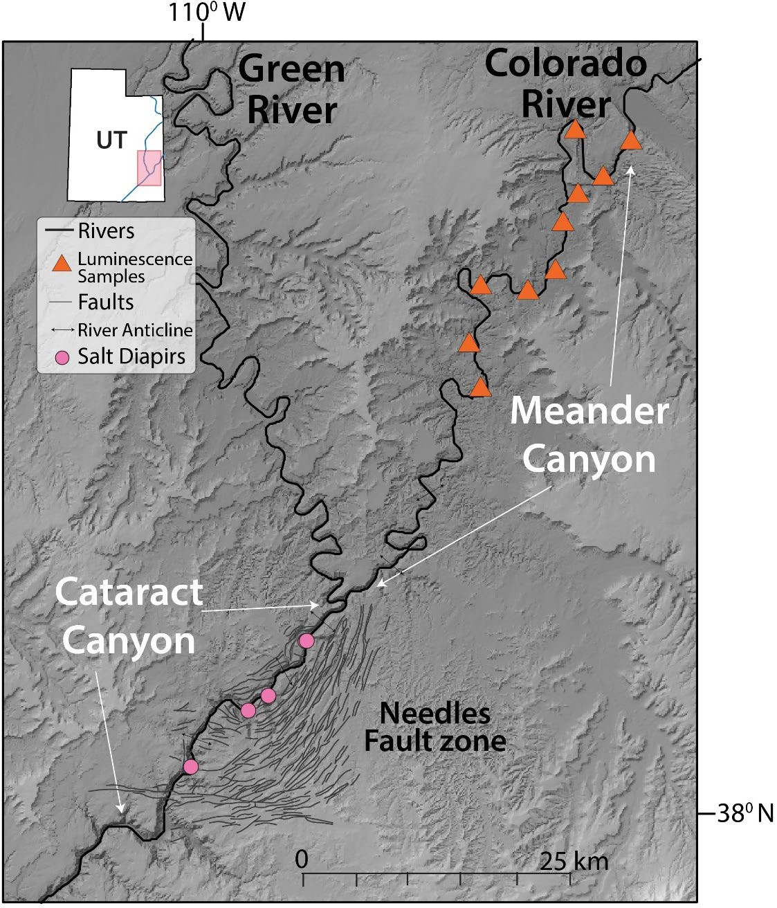
Figures:
Figure 1: Map of study area including general locations of luminescence samples.

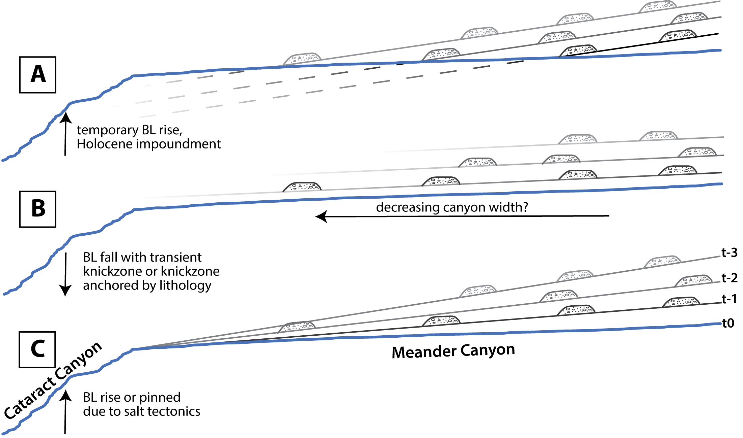
Figure 2: Hypothetical schematic of possible chronostratigraphic relationships between fluvial terraces in Meander Canyon to explain the disappearance of terraces with downstream distance. A) Webb’s (2004) hypothesis of submerging, parallel terraces due to Holocene impoundment by debris flows in Cataract Canyon. Pleistocene terraces follow a steeper gradient than the modern river gradient. B) Preservation of higher terraces decreases downstream as a function of accommodation space. Terraces follow consistent reach gradients. Cataract Canyon is either lithologically anchored in place over time or a transient feature. C) Cataract Canyon is a pinned knickzone due to salt tectonic uplift. Terraces converge while high baselevel is maintained. BL = baselevel
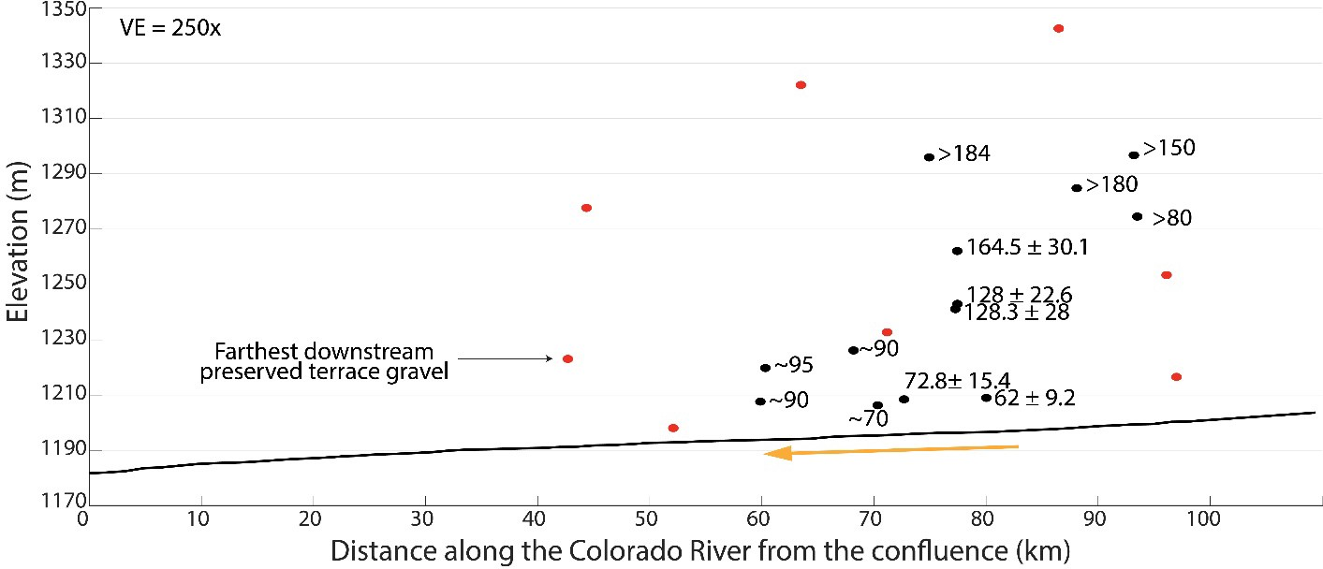
Figure 3: Locations of luminescence samples collected along the length of the Colorado River from the confluence of the Green and Colorado Rivers (start of Cataract Canyon). Known ages include error, while all other listed ages are preliminary. Orange arrow shows increase in age of terrace deposits that are ~10m above modern river grade with decreasing distance towards Cataract Canyon. Red dots are samples that need funding and therefore are on hold for analysis at the Luminescence Lab.

References:
Aitken, M., 1998, Introduction to optical dating: the dating of Quaternary sediments by the use of photon-stimulated luminescence:, https://books.google.com/books?hl=en&lr=&id=yMdT0a_7_XwC&oi=fnd&pg=PR9&ots
=ZwsLco6d2c&sig=lu6zopBybYW8Ve-Hbsz8VrzgaJU (accessed April 2020).
Arnold, L.J., Demuro, M., Parés, J.M., Pérez-González, A., Arsuaga, J.L., Bermúdez de Castro, J.M., and Carbonell, E., 2015, Evaluating the suitability of extended-range luminescence dating techniques over early and Middle Pleistocene timescales: Published datasets and case studies from Atapuerca, Spain: Quaternary International, v. 389, p. 167–190, doi:10.1016/j.quaint.2014.08.010.
Bursztyn, N., Pederson, J.L., Tressler, C., Mackley, R.D., and Mitchell, K.J., 2015, Rock strength along a fluvial transect of the Colorado Plateau - quantifying a fundamental control on geomorphology: Earth and Planetary Science Letters, v. 429, p. 90–100, doi:10.1016/j.epsl.2015.07.042.
Cook, K.L., Whipple, K.X., Heimsath, A.M., and Hanks, T.C., 2009, Rapid incision of the Colorado River in Glen Canyon - insights from channel profiles, local incision rates, and modeling of lithologic controls: Earth Surface Processes and Landforms, v. 34, p. 994– 1010, doi:10.1002/esp.1790.
Elliott, C., 2002, Relationships between tributary catchments, valley-bottom width, debris-fan area, and mainstem gradient on the Colorado Plateau: A case study in Desolation and:, https://digitalcommons.usu.edu/etd/6727/ (accessed July 2020).
Furuya, M., Mueller, K., and Wahr, J., 2007, Active salt tectonics in the Needles District, Canyonlands (Utah) as detected by interferometric synthetic aperture radar and point target analysis: 1992-2002: Journal of Geophysical Research: Solid Earth, v. 112, p.
1992–2002, doi:10.1029/2006JB004302.
Geiger, F., 2014, Landscape evolution of the needles fault zone, Utah, Investigated through chronstratigraphic and terrain analyses:, doi:10.1192/bjp.112.483.211-a.
Grams, P.E., and Schmidt, J.C., 1999, Geomorphology of the Green River in the eastern Uinta Mountains, Dinosaur National Monument, Colorado and Utah: Varieties of fluvial form, p. 81–111.
Hack, J.T., Seaton, F.A., and Nolan, T.B., 1957, Studies of Longitudinal Stream Profiles in Virginia and Maryland UNITED STATES DEPARTMENT OF THE INTERIOR:, https://pubs.usgs.gov/pp/0294b/report.pdf.
Hanks, T.C., and Webb, R.H., 2006, Effects of tributary debris on the longitudinal profile of the Colorado River in Grand Canyon: Journal of Geophysical Research: Earth Surface, v.
111, p. 1–13, doi:10.1029/2004JF000257.
Huntley, D., Godfrey-Smith, D., and Nature, M.T.-, 1985, Optical dating of sediments: Springer, https://link.springer.com/content/pdf/10.1038/313105a0.pdf (accessed April 2020).
Huntoon, P., 1982, The Meander anticline, Canyonlands, Utah: An unloading structure resulting from horizontal gliding on salt:, doi:10.1192/bjp.112.483.211-a.
Jochems, A.P., and Pederson, J.L., 2015, Active salt deformation and rapid, transient incision along the Colorado River near Moab, Utah: Journal of Geophysical Research: Earth Surface, v. 120, p. 730–744, doi:10.1002/2014JF003169.
Kravitz, K., Upton, P., Mueller, K., and Roy, S.G., 2017, Topographic controlled forcing of salt flow: Three-dimensional models of an active salt system, Canyonlands, Utah: Journal of Geophysical Research: Solid Earth, v. 122, p. 710–733, doi:10.1002/2016JB013113.
Mcgill, G.E., and Stromquist, A.W., 1975, Origin of graben in the Needles District,

Canyonlands National Park, Utah: Four Corners Geol. Soc. Guidebook, 8th Field Conference, p. 235–243, http://archives.datapages.com/data/fcgs/data/013/013001/235_four- corners130235.htm (accessed April 2020).
McGill, G.E., and Stromquist, A.W., 1979, The grabens of Canyonlands National Park, Utah: Geometry, mechanics, and kinematics: Journal of Geophysical Research, v. 84, p. 4547, doi:10.1029/JB084iB09p04547.
Murray, A.S., and Wintle, A.G., 2000, Luminescence dating of quartz using an improved single-aliquot regenerative-dose protocol: Radiation Measurements, v. 32, p. 57–73, doi:10.1016/S1350-4487(99)00253-X.
Nelson, M.S., Gray, H.J., Johnson, J.A., Rittenour, T.M., Feathers, J.K., and Mahan, S.A., 2015, User Guide for Luminescence Sampling in Archaeological and Geological Contexts: Advances in Archaeological Practice, v. 3, p. 166–177, doi:10.7183/2326-3768.3.2.166.
Pazzaglia, F.J., 2013, 9.23 Fluvial Terraces:, http://citeseerx.ist.psu.edu/viewdoc/download?doi=10.1.1.211.535&rep=rep1&type=p df (accessed April 2020).
Pederson, J.L., and Tressler, C., 2012, Colorado River long-profile metrics, knickzones and their meaning: Earth and Planetary Science Letters, v. 345–348, p. 171–179, doi:10.1016/j.epsl.2012.06.047.
Rhodes, E.J., 2011, Optically Stimulated Luminescence Dating of Sediments over the Past 200,000 Years: imedea.uib-csic.es, v. 39, p. 461–488, doi:10.1146/annurev-earth-
040610-133425.
Rittenour, T.M., 2008, Luminescence dating of fluvial deposits: applications to geomorphic, palaeoseismic and archaeological research: Boreas, v. 37, p. 613–635, doi:10.1111/j.1502-3885.2008.00056.x.
Stromquist, A., 1976, Geometry and growth of grabens, Lower Red Lake Canyon area, Canyonlands National Park, Utah:, https://digitalcommons.usu.edu/crc_research/293/ (accessed March 2021).
Webb, R., Belnap, J., and Weisheit, J., 2004, Cataract Canyon: a human and environmental history of the rivers in Canyonlands:, https://digitalcommons.usu.edu/crc_research/279/ (accessed April 2020).

