RMS-SEPM Application Donald L. Smith Research Grant

Eocene Basin Record of Metamorphic Core Complex Exhumation in the Western United States Cordillera
Haley Thoresen

Hypothesis
The western United States Cordillera contains evidence for multiple phases and styles of extension in the Cenozoic. The onset of Basin and Range extension is well-constrained at 17 Ma (1), but extension along low-angle detachment faults may have initiated as early as 55 Ma. Across Idaho and Montana, Eocene sedimentary rocks record a period of widespread basin formation and filling that has been linked to rapid metamorphic core complex (MCC) exhumation (Deer Lodge Valley) and episodic collapse of structural culminations (Salmon and Muddy Creek) (2,3,4) (Fig. 1). The problem is that existing chronometry does not constrain the earliest phase of extension or the relationship between deformation and basin evolution, which are key to deciphering the distribution of extensional styles and drivers for MCC formation. I hypothesize that the onset of extensional deformation and basin ponding in collapse basins (Salmon and Muddy Creek) ensues widespread volcanism associated with the Lowland Creek and Challis volcanic fields. Magmatism thermally weakened thickened crust, initiating extensional collapse. The basin adjacent to the Anaconda MCC (Deer Lodge Valley) is syntectonic, and there will be short lag times (<10 mya) in early coarse grained lithofacies, representing the onset of rapid exhumation.

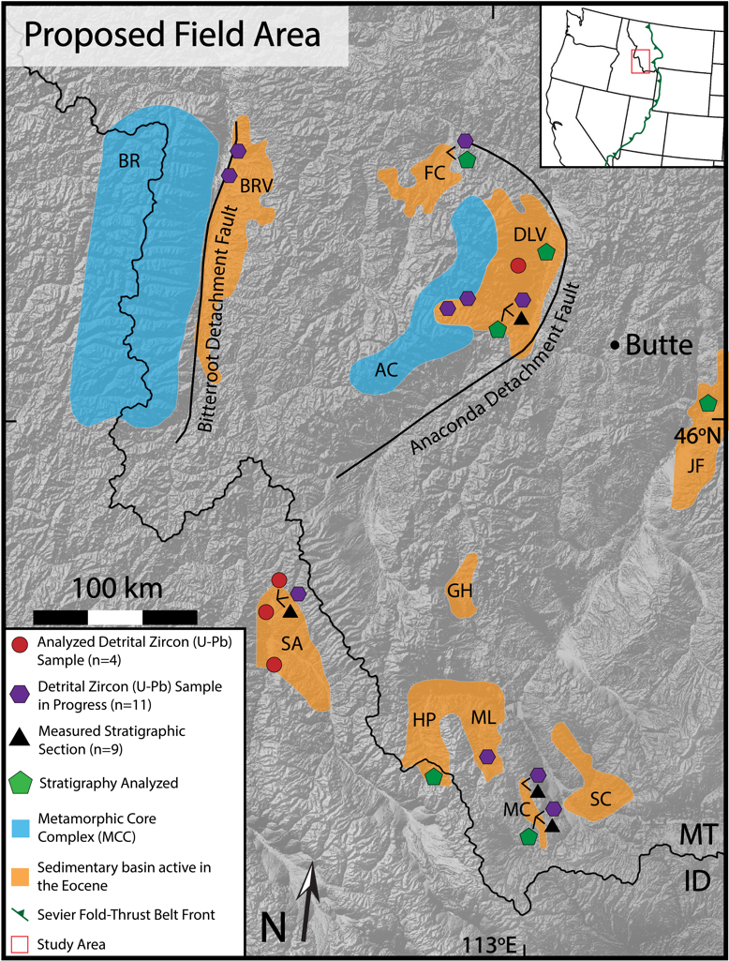
Figure 1: Proposed field area with sample and measured stratigraphic section localities, basins active in the Eocene, and metamorphic core complexes (MCC). Bitterroot MCC (BR), Anaconda MCC (AC), Bitterroot Valley (BRV), Flint Creek (FC), Deer Lodge Valley (DLV), Salmon (SA), Horse Prairie (HP), Medicine Lodge (ML), Muddy Creek (MC), Sage Creek (SC), Jefferson (JF), Grasshopper (GH). Basin locations from (Constenius, 1996).

Research Plan
Previous work dating MCC exhumation, primarily using bedrock thermochronology, resulted in a range of exhumation ages (52-40 Ma) and rates of extension (4,5), but no studies have determined how MCC exhumation and basin formation are related. The Muddy Creek and Salmon basins have been studied using stratigraphy, structural analysis, and stable isotope geochemistry (3,6,7). Both basins are thought to have been a part of a Cretaceous paleovalley

that filled with volcanic rocks prior to a major phase of extension along low-angle detachments (3,7). The stratigraphic shift from ignimbrites and tuffaceous fluvial sandstone and conglomerate to organic-rich lacustrine mudstone and limestones may represent the transition from valley fill to extension and basin ponding.
To test my hypothesis, I will conduct a detailed stratigraphic, geochronologic, and thermochronologic investigation of basin strata associated with the Anaconda MCC and the surrounding Muddy Creek and Salmon basins (Fig. 1). I will measure decimeter scale- stratigraphic sections and paleocurrent indicators to determine depositional environments, basin architecture, and (combined with detrital U-Pb ages) sediment provenance. I will use sanidine 40Ar/³⁹Ar dating of interbedded tuffs to obtain depositional age control. By comparing these improved depositional ages to previously dated Lowland Creek and Challis Volcanics (6), I will determine the temporal relationship between volcanism and basin formation. Using detrital zircon (U-Th)/(He-Pb) double dating, I will obtain crystallization and cooling ages of targeted age clusters (8) in order to calculate lag times (tL=tc-td): an individual grain’s travel time from cooling (tc) to deposition (td) (8,9). Different basin subsidence mechanisms will create distinct relationships between lag time, cooling age, and depositional age (Fig. 2) (8,9). I will compare these variables to determine the timing of initial MCC exhumation, how changes in basin architecture correlate to unroofing, and the early differences between extensional styles.
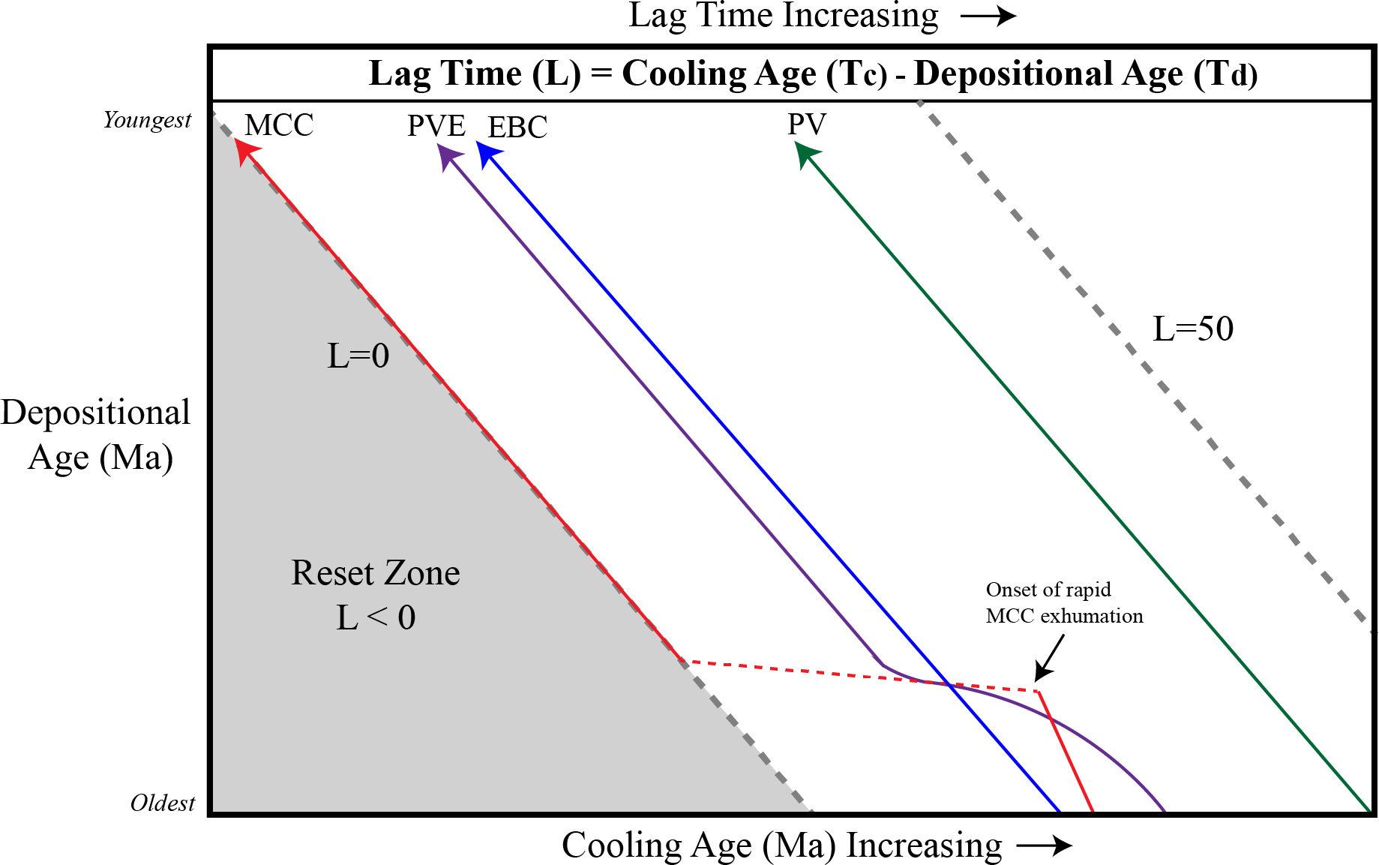

Figure 2:Expected trends in lag time based on basin forming mechanisms. Cooling age is detrital zircon (U-Th)/He age of youngest, non-volcanic population. Metamorphic core complex (MCC), Paleovalley to Extensional Basin (PVE), Extensional basin with constant subsidence rate (EBC), Paleovalley filling (PV). Dashed gray lines represent lines of equal lag time.

Table 1 shows an expected timeline for field work, sample prep, and analyses. Detrital zircon (U-Pb) analyses are in progress at the University of Texas, Austin. I am leveraging published ⁴⁰Ar/³⁹Ar ages of Lowland Creek volcanics (10) and separating sanidine from collected samples to run at the University of Wisconsin. Receiving this grant will provide funding for field work during the summer of 2021, which is crucial for measuring additional stratigraphic sections and determining basin architecture (Fig. 1).

Scientific and Societal Significance
The collapse of the North American Cordillera is a continental scale tectonic process that is critical to our understanding of how extension is accommodated in the lithosphere. The northwest trending line of MCCs extending from Mexico to Canada is characterized by three regions with varying exhumation ages (Eocene-Miocene) and magnitudes of extension (> 10 km): The Northern Belt, Central Belt, and Southern Belt (11). These MCCs are thought to represent the location of the thickest crust in the Sevier Hinterland pre-extension and are a type- locality for understanding MCC dynamics in a continental setting (11). Exhumation in the Northern Belt, which includes the Anaconda and Bitterroot MCCs, and basin subsidence may have coincided in time with a change of tectonic driving force from compression to extension, but a change in plate boundary conditions is not an adequate explanation for high-magnitude extension here, as is often cited for MCCs in the Central Belt (1,8,11). The removal of the Farallon slab following Laramide compressional deformation is proposed to have occurred as early as ca. 55 Ma, initiating voluminous magmatism in the Challis, Absaroka, and possibly Lowland Creek volcanic provinces (12,13). Improved temporal resolution on MCC exhumation and basin subsidence can help us determine if shallow slab removal and/or delamination was coeval with extension, or if volcanism associated with this renewed magmatism was necessary to thermally weaken the lithosphere, triggering extensional subsidence (13).
The formation of the Salmon and Muddy Creek basins is proposed to have occurred along low-angle detachment faults at Sevier structural culminations (2,3). While these detachment faults have similar geometries to those related to the exhumation of MCCs, the high gravitational potential energy of that culmination did not result in the formation of an MCC. The factors controlling this uneven distribution and magnitude of extension in the lithosphere are not well understood. This study will provide insights into the relationship between deformation and basin formation, constraining the role MCC exhumation plays in basin subsidence and ponding. Deciphering extensional styles and drivers of MCC formation are crucial to our understanding of the mechanical processes contributing to collapsing lithosphere, the role that MCCs play in the differentiation of crust, and the evolution of orogenic belts through geologic time (11).

Table 1: Detailed Expected Timeline
Spring 2021 | Conduct initial detrital zircon (U-Th)/He analysis at the end of April at the University of Texas, Austin.  Separate sanidines from Lowland Creek Tuff beds for 40Ar/39Ar age control; send for radiation through WiscAr at the  University of Wisconsin.
Summer 2021 | Conduct five weeks of field work, collecting additional samples and measuring detailed stratigraphic sections in the Deer Lodge Valley and other Eocene Basins (Fig. 1).  Continue processing detrital zircon  samples for additional analyses.
Fall 2021 | Conduct additional (U-Th)/He analyses, focusing on detrital zircon populations that represent the bottom and top of each section.  Start processing newly collected samples from field season.  Present initial data at 2021 GSA Annual  conference.
Winter 2021/2022 | Model (U-Th)/He results. Continue processing newly collected samples. Start drafting stratigraphy manuscript. Present research at AGU.
Rest of 2022 | Write up manuscript to publish stratigraphy.

References
- Colgan, J.P., et al., 2006, Cenozoic Tectonic Evolution of the Basin and Range Province in Northwestern Nevada: American Journal of Science, v. 306, p. 616-654
- Constenius, K.N., 1996, Late Paleogene extensional collapse of the Cordilleran foreland fold and thrust belt:
Geological Society of America Bulletin, v. 108, p. 20-39
- Janecke, S.U., et al., 2000, Long-distance longitudinal transport of gravel across the Cordilleran thrust belt of Montana and Idaho: Geology, v. 28, p. 439-442
- O’Neill, M.J., et al., 2004, Early Tertiary Anaconda Metamorphic Core Complex, southwestern Montana:
Canadian Journal of Earth Sciences, v. 41, p. 63-72
- Foster, D.A., et al., 2010, Extension of the Anaconda metamorphic core complex: 40Ar/39Ar thermochronology and implications for Eocene tectonics of the northern Rocky Mountains and the Boulder batholith: Lithosphere, v. 2, p. 232-246
- Blankenau, J.J., 1999, Cenozoic structural and stratigraphic evolution of the southeastern Salmon Basin, eastcentral
Idaho (Masters thesis): Utah State University, 241 p.
- Methner, K., et al., 2015, Eocene and Miocene extension, meteoric fluid infiltration and core complex formation in the Great Basin (Raft River Mountains, Utah): Tectonics, v. 34, p. 680-693
- Canada, A.S., et al., 2019, Accelerating exhumation in the Eocene North American Cordilleran hinterland; Implications from detrital zircon (U-Th)/(He-Pb) double dating: Geological Society of America Bulletin, v. 132, p. 198-214
- Painter, C.S., et al., 2014, Exhumation of the North American Cordillera revealed by multi-dating of Upper Jurrassic-Upper Cretaceous foreland basin deposits: GSA Bulletin, v. 126, p. 1439-1464
- Dudás, F.Ö., et al., 2010, 40Ar/39Ar Geochronology and Geochemical Reconnaissance of the Eocene Lowland Creek Volcanic Field, West-Central Montana: The Journal of Geology, v. 118, p. 295-304
- Whitney, D.L., et al., 2013, Continental and oceanic core complexes: GSA Bulletin, v. 125, p. 273-298
- Chetel, L.M., et al., 2011, Paleogeographic reconstruction of the Eocene Idaho River, North American Cordillera: GSA Bulletin, v. 123, p. 71-88.
- Smith, M.E., et al., 2014, Paleogeographic record of Eocene Farallon slab rollback beneath western North America: Geology, v. 42, p. 1039-1042

